Organic Chemistry Lab Report 3
Experiment VII: Separation of three organic compounds..
Title: The Separation of Three Organic Compounds by Acid-Base Reactions, a Liquid-Liquid Extractions.
Molecules:
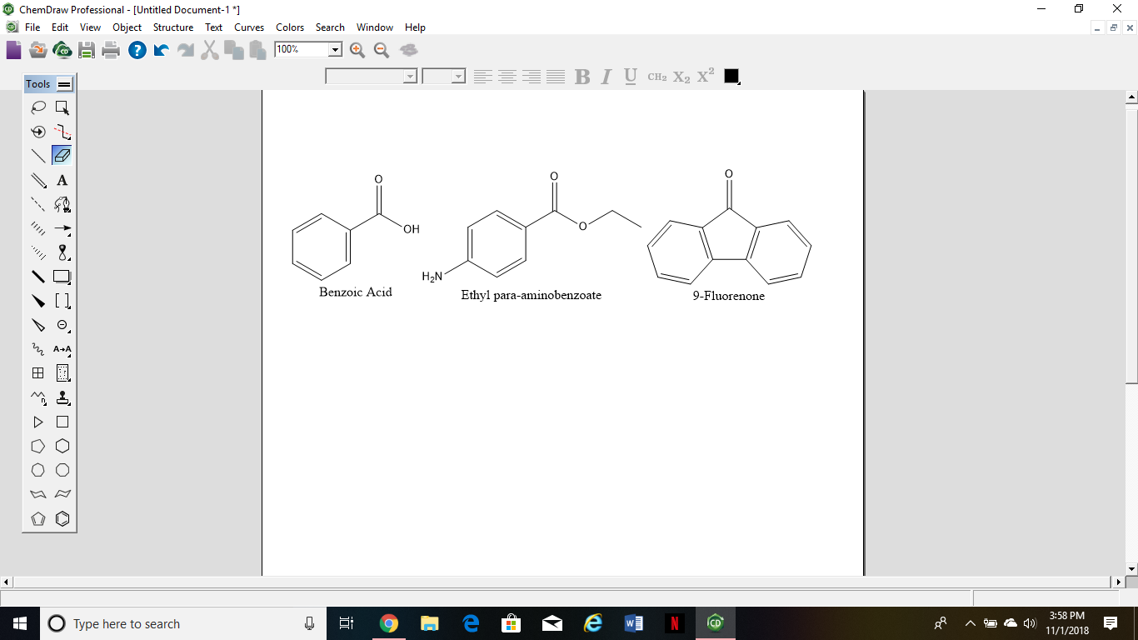

Abstract:
During this laboratory, we performed the separation of three organic compounds, an acid (Benzoic acid), a base (Ethyl para-aminobenzoate *a.k.a. Benzocaine) and a neutral compound (9- Fluorenone). In order to reach this separation, we used the other liquid-liquid extraction name: the acid-base reactions and the liquid-liquid extraction. We have seen the liquid-liquid extraction before, however it was based on polarity. In this lab, we performed the second one, based on acid-base. This process is used to separate a basic compound (benzocaine) from an organic mixture. However, it is also used to separate the acid from different compounds. The use of an acid (ex: hydrochloric acid) or a base (ex: sodium hydroxide) is necessary in order to perform the reactions. To start, we had 55 mg of both 9-fluorene and benzocaine, and 54mg of benzoic acid. At the end of the experience, we had 22 mg of benzoic acid, 27 mg of benzocaine and 46 mg of 9-Fluorene, showing a percent recovery of 41%, 49% and 84%. In addition, we used the machine called the “melting point apparatus” in order to find the melting point of each compound. I found Benzoic acid: 121.5ºC, Benzocaine: 88.5ºC, and 9-fluorene: 79.8ºC
Procedure:
We have followed the procedure from the textbook “Organic Chemistry I” written by Zachary J. Poulos (Poulos,Z. J., Organic Chemistry I - “A Laboratory Manual for the Health Science Major,” Fall 2018; Hayden-McNeil; Plymouth, MI, 2018. pp 106-111. As differences, we did not mass ourselves the benzoic acid and the 9-Fluorene, instead they were given by the instructor. In addition, instead of starting with 50 mg of each compound, I started with 54mg, 55mg and 55mg. The difference does not make any differences because my ratio is still almost 1:1:1. Otherwise, we followed everything.
Reactions: (drew by hand.)
- Protonation of benzocaine to benzocaine hydrochloride.

- Deprotonation of the benzocaine hydrochloride to reform benzocaine .

- Deprotonation of benzoic acid to sodium benzoate.

- Protonation of the sodium benzoate to form benzoic acid.

Data and Calculations:
COMPOUND | INITIAL MASS (mg) | FINAL MASS (mg) | MELTING POINT (ºC) | PERCENT RECOVERY (%)
Benzoic Acid | 54 mg | 22 mg | 121.5ºC | 41%
Benzocaine | 55 mg | 27 mg | 88.6ºC | 49%
9-Fluorene | 55 mg | 36 mg | 79.8ºC | 65%

I compare my results of melting point with the results provide in Zachary J. Poulos’ book “Organic Chemistry I” in order to seek the purity of my final compound. The result from the book are Benzoic acid 122.12ºC, Benzocaine 88-90ºC, and 9-fluorene 83.5ºC. Comparing these results to mine, I can see that my compounds seem almost 100% pure.

Discussion and Conclusion:
In this experiment, lot of chemistries happen. Indeed, the first reaction where benzocaine will separate from the two other compounds by reacting with the hydrochloric acid. Through this process, the amino group in benzocaine is protonated by the hydronium ion $H_{3}O{}^{+}.$From this, the reaction will create the conjugate acid of benzocaine and hydrochloric acid, named benzocaine hydrochloride. We performed this extraction twice (a 2$×2 mL$3M (molarity mol/L) HCL extraction) In order to provide more protons and so being able to separate all the benzocaine. Benzocaine hydrochloride endergo then a freebase reaction where 6M of sodium hydroxide (NaOH) are added. The goal behind this is to loose the proton gained during the separation from the two other compounds.
The tube containing benzocaine hydrochloride is immersed into a ice-water bath in order to chill the solution. The purpose of cooling the conjugate acid is to avoid that it undergoes ester hydrolysis as well as decrease the solubility of benzocaine which will lead to an increase of the percent isolation. The final compound undergoes finally a vacuum filtration with possibility of reusing the mother liquor to help rinsing it.
In another time, the remaining part of the first tube contains benzoic acid and 9-fluorene will go through a different reaction in order to separate the acid and the neutral compounds. In this case, we directly added sodium hydroxide. The purpose is that the base NaOH will react with the benzoic acid. Benzoic acid will be deprotonated by the hydroxide ion. Two immiscible phases appear with at the top the final product of the acid-base reaction which is the conjugate base, name sodium benzoate and the bottom part with still the neutral compound 9-fluorene. The conjugate base is then mixed with hydrochloric acid in order to get back to its acid around a pH 2. Sodium benzoate is protonated and its conjugate acid will be benzoic acid. Ice-water bath is also used in this experiment in order to complete the precipitation of benzoic acid. Finally, we also used vacuum filtration in order to separate the solid and liquid part of the solution. Water is used to make sure that everything is passing through the vacuum filtration, however, water plays a role of spectator because it does not influence the reaction.
In our final case, we have the separation and isolation of the last compound: 9-fluorene. Indeed we first washed it with water$(H_{2}O)$in order to remove the excess of sodium hydroxide. As we know, 9-fluorenone is not soluble in water, however sodium hydroxide is soluble in water. From that, two immiscible phases form with the top one containing water and sodium hydroxide and the bottom organic layer containing dissolve 9-fluorene. This dissolved compound will then dry of water because some may have mixed with it (around 3%). For that, we used granulated, anhydrous sodium sulfate $({Na}_{2}{SO}_{4})$. The principle is that the salt will dry the water. Finally, the final liquid is undergoing gravity filtration through a column of anhydrous sodium sulfate. This column does two things: the first one is that it acts as a last line of drying defense while for the second utility is that it filters undesired solids.
I have compared my results with some of my classmate and we got roughly the same amount at the end. However, one thing crossed my mind: the neutral compound does not react in any way, however we lost some of it at the end of the experiences. Indeed, from 54 mg of benzoic acid, we collected 22 mg, which makes sense because some of them were used for the acid-base reaction. We have roughly the same ratio for benzocaine. However, we did not use any 9-fluorene to reacts with anything, but still we lost some. This looses of product can be assimilated to errors made.
As source of errors, I think that one of the primary is when we separated the two phase, some of the unwanted product ended up in the pipette. Secondly, I would say that when I vacuum filtered, some of the product may be left on the erlenmeyers. Finally, when I had to transfer the product from the filtration to the aluminium dishes, some of it dropped on the table.
Analysing the IR spectrum for each compounds was not really difficult due to the fact that they, for all three have similars groups. Indeed, all three of them have a C=O stretch at 1678 for Benzoic acid, 1711 for 9-fluorene and 1679 for benzocaine. In addition, all three have a ring C=C stretch from 1400 to 1600. The last common point that they have, it is the =C-Hoop bend from 650 to 800. Now, for the different groups, benzoic acid has a O-H stretch from 2555 to 3071 and a C-O stretch at 1289. Benzocaine too possess the C-O stretch at 1273. However, benzocaine has also ann amino group N-H stretch from 3222 to 3454, a C-N stretch from 1109 to 1123 and finally a ${sp}^{3}$from 2900 to 2984. The only difference for 9-fluorene, is the C-H stretch at 3060 and 3396. (IR provided on the hard copy paper).

